**People’s Democratic Republic of Algeria**

**Ministry of Higher Education and Scientific Research**

**Ibn Khaldoun University –Tiaret**

**Faculty of Mathematics and Computer**

**Science department**

Report N°2 on the practical work Advanced Data Base

**Supervised By:**

**Mr Abdelkader OUARED**

**Presented by :**

* **Abdelhakim Azzouz**
* **Chaouki Nouar**
* **Youcef Yslem Kharroubi**

In this exercise we will look at how SAVEPOINT, ROLLBACK and COMMIT commands work.

* First start MySQL server in XAMPP;
* Run MySQL Workbench;

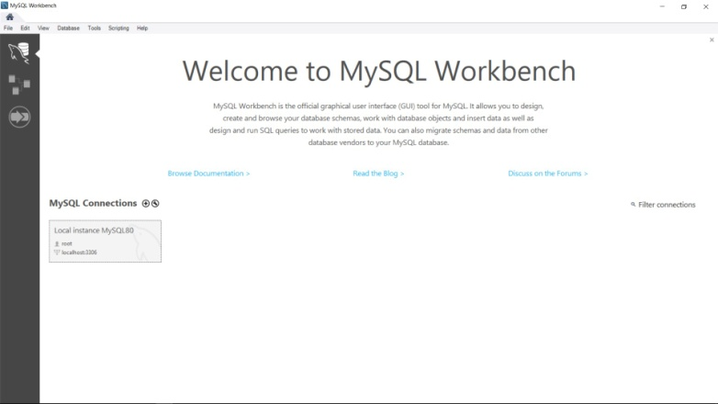

* Click on « Local instance MySQL80 »

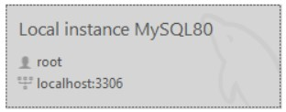

We’ll get the following window :

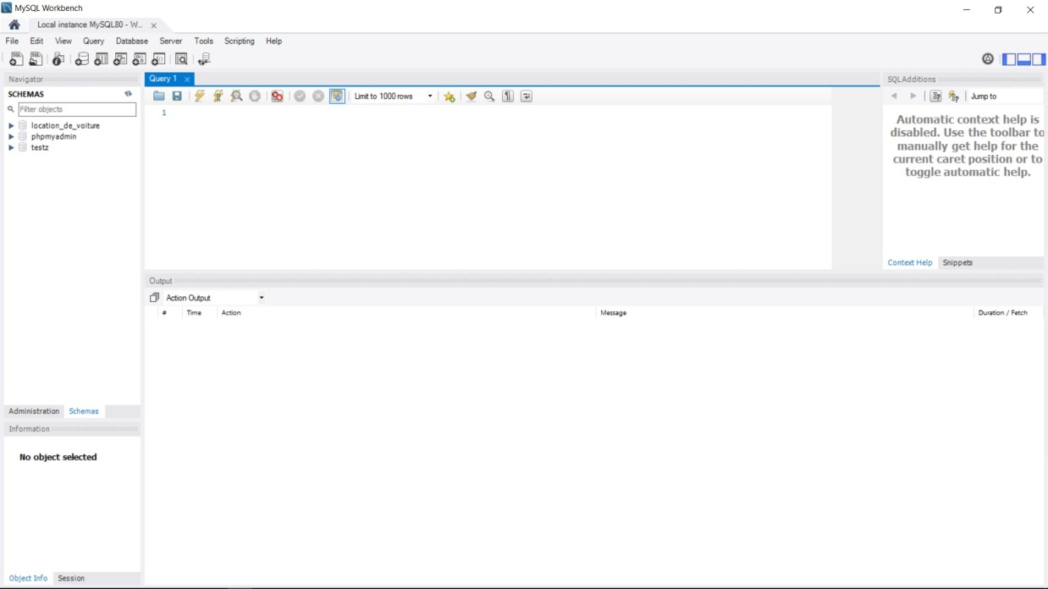

* In the « Query 1 » tab let’s create a new schema called ‘schema’

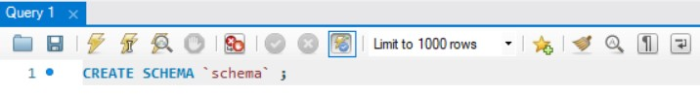

Click on the « Execute » buttonScreenshot 2021-01-21 201315.jpg

The SQL query is executed successfully



In the « Navigator » section the newly created schema doesn’t appear

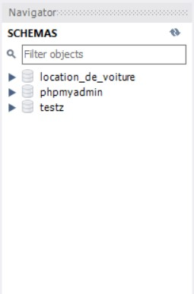

After clicking the « Refresh » button the new schema appearScreenshot 2021-01-21 201502.jpg

* Let’s create a table in the schema

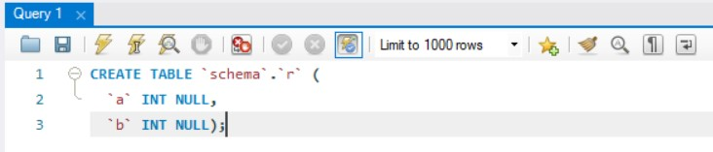

The query is successfully executed:

Screenshot 2021-01-21 201643.jpg

and the table is shown in the “ Navigator “ section

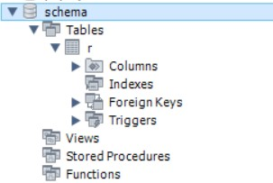

* Set autocommit to 0

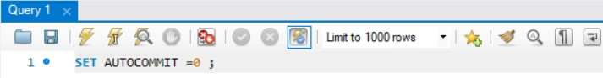

Screenshot 2021-01-21 201913.jpg

When autocommit is set to 0, the transactions made are not validated automatically.

* In « Navigator » section select « schema » by double-clicking on it

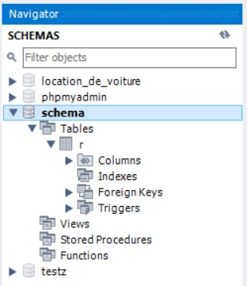

* The newly created table (“r”) is empty as shown below:

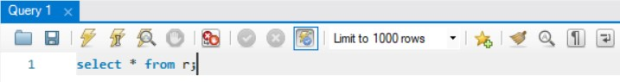

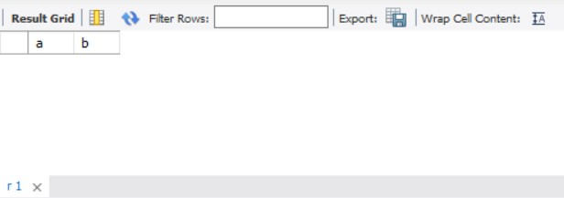

* Insert a new row with 5 and 6 values

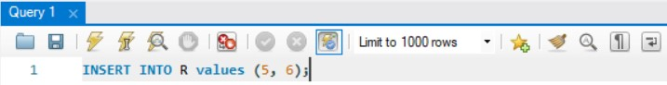

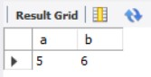

* Create a new savepoint with the SAVEPOINT command and name it “my_savepoint_1”:

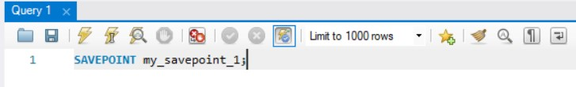

We use the SAVEPOINT to identify a point in a transaction to which we can later roll back.

* Insert a new row with 7 and 8 values

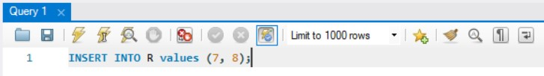

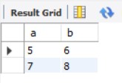

* Create a new savepoint with the SAVEPOINT command and name it “my_savepoint_2”:

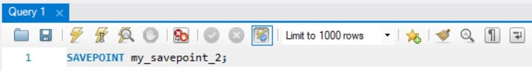

* Insert a new row with 7 and 8 values

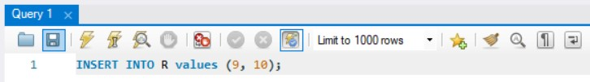

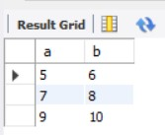

* Let’s test the ROLLBACK command and see what happens:

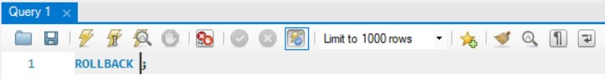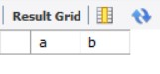

As we can see there are no rows to display that’s because ROLLBACK reverts all the changes since last COMMIT or ROLLBACK.

* After that let’s try to rollback to my_savepoint_1 to see if, after rolling back to the last COMMIT, the ROLLBACK command reverts to that specific point

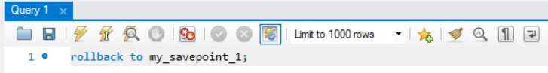

Screenshot 2021-01-21 211017.jpg

As we can see the command doesn’t execute, that’s because the savepoint created earlier was reverted back in the previous ROLLBACK command.

* Insert back the reverted rows and savepoints as shown below:

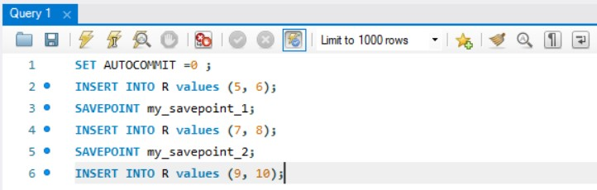

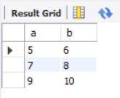

* Use ROLLBACK command to revert back to a specific savepoint :

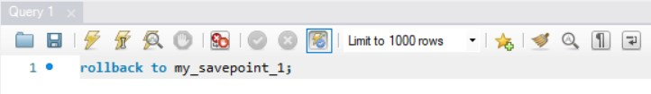

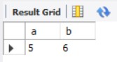

As we can see, when specifying the savepoint, the ROLLBACK command reverts all transactions made back to that specific savepoint.

* Add the following two rows to the table:

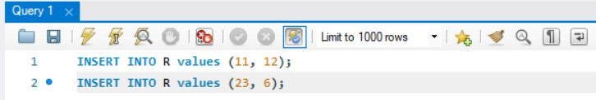

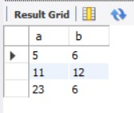

* Close the MySQL Workbench window and then reopen it.

After closing and reopening the MySQL Workbench window, try displaying all the rows of the “r” table:

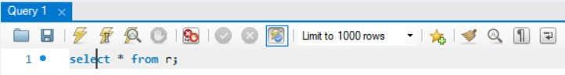

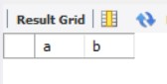

As we can see, even though we did insert rows previously, the response of the query doesn’t display any row, that’s because the autocommit was set to the value of 0 and we did not commit (validate) all the transactions made before.

* Insert back the reverted rows and savepoints as shown below:

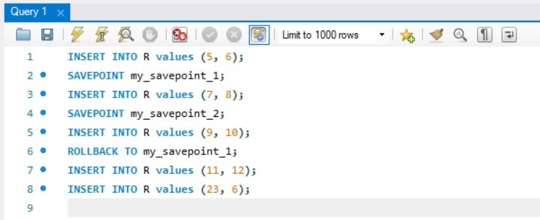

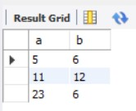

* Use the COMMIT command to validate all the transactions made until now:

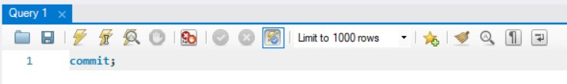

Screenshot 2021-01-21 213326.jpg

According to the documentation, we use the COMMIT statement to end the current transaction and make permanent all changes performed in the transaction.

* Now again, close and reopen the MySQL Workbench window, and check if the “r” table does contain the inserted rows:

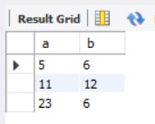

As we can see, the rows are still in the table, that’s because all the changes made through the transaction were “validated” using the COMMIT command.

* Set the value of autocommit to 0:

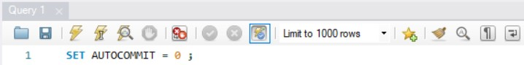

* Add more rows and savepoints as shown below:

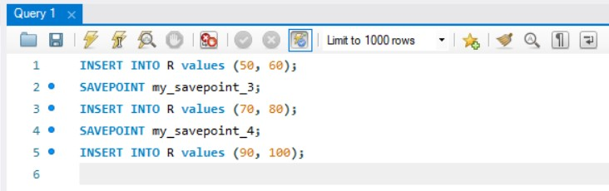

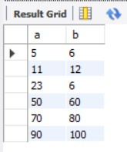

* Revert the changes back to “my_savepoint_3” using ROLLBACK command:

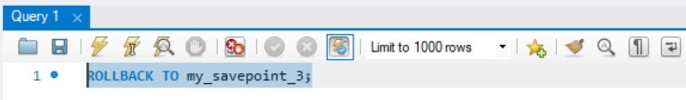

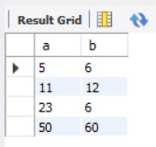

* Let’s try to revert back to “my_savepoint_1”:

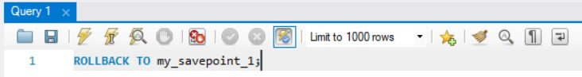

Screenshot 2021-01-21 214229.jpg

As we can see, the command didn’t execute, that’s because “my_savepoint_1” savepoint is no longer available.

The content of the “r” table is still the same

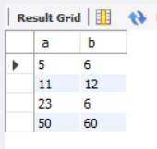

* Let’s try to use the ROLLBACK command without specifying any particular savepoint and see what happens:

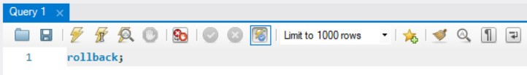

Screenshot 2021-01-21 214458.jpg

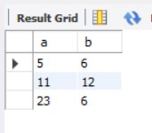

As we can see above, the ROLLBACK command reverted changes made to the table since to the last COMMIT.